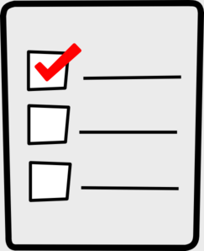
Weekly Checklist
Week of April 20th

Required Assignments | Required Assignments
Math:  - Video for 12.6  - 12.6 Homework (regular OR Challenge)  - Video for 12.7  - 12.7 Homework (regular OR Challenge)  Science:  - Video for pages 24-31  - Questions for pages 24-31 | Reading:  - Journal prompts  - Good Morning Sunshine or Miss Morgan’s students do their Fluency passage  - Figurative Language Video  - Figurative Language quiz  - Khan Academy assignment  - Helping Verb Video  - Helping Verb quiz  - Comprehension Cards  Social Studies:  - Midwest video  - Questions about the video

